Hold Payouts during partner bank unavailability
Author/s: Vishnu Jampala
Team/Pod: Payouts | BU: RazorpayX
Published Date:

Reviewer Name | Reviewed Date | Status
 |  | Not started

Table of Contents

1. Problem Statement 2
2. Introduction & Scope 3
2.1. Relevant Resources 3
3. Out of Scope 3
4. Futuristic Scope 3
5. Assumptions, Goals & Non-Goals 3
5.1. Assumptions: 3
5.2. Goals: 3
5.3. Non-Goals: 4
6. Current Architecture / Current HLD 4
7. Final Approach - Specifications 4
7.1. List of Possible Solutions 4
7.2. Assumptions 4
7.3. Possibility of Open Sourcing 5
7.4. Possibility on Patent 5
7.5. Data model/Schema Changes 5
7.6. Business Logic Changes 5
7.7. Miscellaneous Questions 5
8. Non Functional Requirements (NFRs) 6
8.1. Scalability 6
8.2. Availability 6
8.3. Security 6
8.4. Compliance 6
8.5. Reliability 6
8.6. Infra Cost 6
9. Feature Dependencies & SLAs 6
9.1. Upstream Dependencies 6
9.2. Downstream Dependencies 6
10. Testing Plan 7
10.1. Test Cases 7
10.2. UAT Testing 7
10.3. Performance/Load testing 7
11. Go-live plan 7
11.1. Production Rollout and Ramp plan 7
11.2. Backward Compatibility 7
11.3. Rollback plan 7
12. Monitoring & Logging 8
13. Milestones & Timelines 8
14. Glossary 8
15. Appendix 8

💡Note

Read following docs to get expert on different topics -
- Format and Structure Your Doc
- How to document code in Google Doc
- API Design Guide
- Put Google Doc in Presentation Mode

Full Reading List - Link

1. Problem Statement
We want to hold payouts for a merchant whenever there isn’t a partner bank available to process the payouts. Reasons for partner bank unavailability for the merchant can be due to:
- Poor performance of all available partner banks.
- Limit exhaustion of NEFT 24x7.
- Non NEFT hours.
- Exhaustion of TPS capacity of all available partner banks.

1 impacts SR/SLA of payouts. 2,3,4 impacts only SLA of payouts as they get queued at the FTS layer. By holding these at the payouts layer, we can provide capability for the merchants to fail/cancel them if needed as part of future scope. Right now, if a merchant wants to cancel such queued payouts stuck at FTS, they raise a support ticket and PSE/devs cancel them using Fail Queued Transfers dashboard action.

2. Introduction & Scope
During partner bank unavailability/degradation for a merchant, they suffer from poor success rate or SLA resulting in bad merchant experience. Payouts sent to the degraded bank get stuck at the bank's end without any final status.

The above issue is addressed to some extent with a feature called Fail Fast. We fail the payout instantly at FTS if all the available partner banks are heavily degraded. So, this helps SLA sensitive merchants as they don’t want their payouts to get stuck for too long at the bank's end.
But fail fast wouldn’t be helpful for non SLA sensitive merchants, they want their payouts to succeed and are okay with delayed processing. For such merchants, we still route the payouts through degraded partner bank resulting in bad merchant experience.The same can be illustrated in a couple of scenarios:
In the case of Virtual Accounts (VA):

- When the partner bank is down and the merchant has routing disabled &
  - Fail fast is triggered
    - We fail the transfer instantly if the fail fast feature is enabled for the merchant.
    - We send the transfer to the degraded partner bank if the fail fast feature isn’t enabled for the merchant.
  - Fail fast isn’t triggered
    - We send the transfer to the degraded partner bank.

- Merchant has routing enabled but when all the available partner banks go down &
  - Fail fast is triggered
    - We fail the transfer instantly if the fail fast feature is enabled for the merchant.
    - We send the transfer to the highest priority degraded partner bank if the fail fast feature isn’t enabled for the merchant.
  - Fail fast isn’t triggered
    - We send the transfer to the highest priority degraded partner bank if the fail fast feature isn’t enabled for the merchant.
In the case of Current Accounts (CA):
- When the partner bank goes down, since we can’t route the transfer and if
  - Fail fast is triggered
    - We fail the transfer instantly if the fail fast feature is enabled for the merchant.
  - Fail fast isn’t triggered
    - We send the transfer to the degraded partner bank.

In all of the above scenarios, the transfer would more often fail or remain in a pending state for an extended period of time resulting in a bad experience to the merchants and also affecting their business flows. By holding the payouts during all such scenarios and subsequently initiating the payout in case the partner bank is back available or providing the ability to the merchant to fail it till a certain SLA improves their experience.
V0 scope
To be able to hold payouts for a merchant when :
- CA partner bank is down.
  - This would be milestone/priority 1.
  - Impact would be high by holding payouts for CA merchants since there isn’t any routing and banks frequently go down.
- All available partner banks are degraded for a VA merchant.
  - This would be milestone/priority 2 since all VA partner banks going down at once is rare.

Upon exceeding the limit of hold payouts SLA, we fail the payout.

2.1. Relevant Resources
Link to Product Spec -
Link to Figma Design -
Link/Description around functional requirements

3. Out of Scope

4. Futuristic Scope
- NEFT 24x7 limit exhaustion and Non NEFT hours.
- Exhaustion of TPS capacity of all available partner banks
- Ability for a merchant to choose if he wants the payout to fail or send it to the bank after On hold SLA expires.
- Ability for the merchant to cancel the payout when it is in On Hold state.

5. Assumptions, Goals & Non-Goals

5.1. Assumptions
NA

5.2. Goals

5.3. Non-Goals

6. Current Architecture / Current HLD
Similar to partner banks, beneficiary banks also degrade and processing payout during that time will result in a failure or payout getting stuck at beneficiary end. So, we need to hold payouts for bene bank degradations and we have already built a feature for it.

- If On hold feature is enabled for the merchant, before sending the payout to FTS, we check the bene bank health.
- If the bank is down, payout goes into on_hold state and waits till it comes back up or payout will fail if SLA is breached.
- A cron job is configured to check merchant SLA and cancel payout if SLA is breached.
- A random generator is used to send 10% of traffic to FTS which is required for bene bank uptime detection.
- FTS sends webhook events of bene bank downtime/uptime and Payouts store them in redis.
- When FTS sends a bene bank uptime event, all payouts associated to that bene bank are fetched and are pushed to the queue for slow processing.
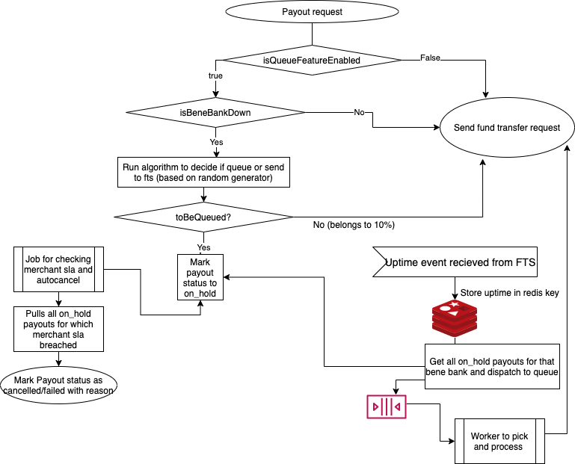

7. Final Approach - Specifications

7.1. List of Possible Solutions
High Level design: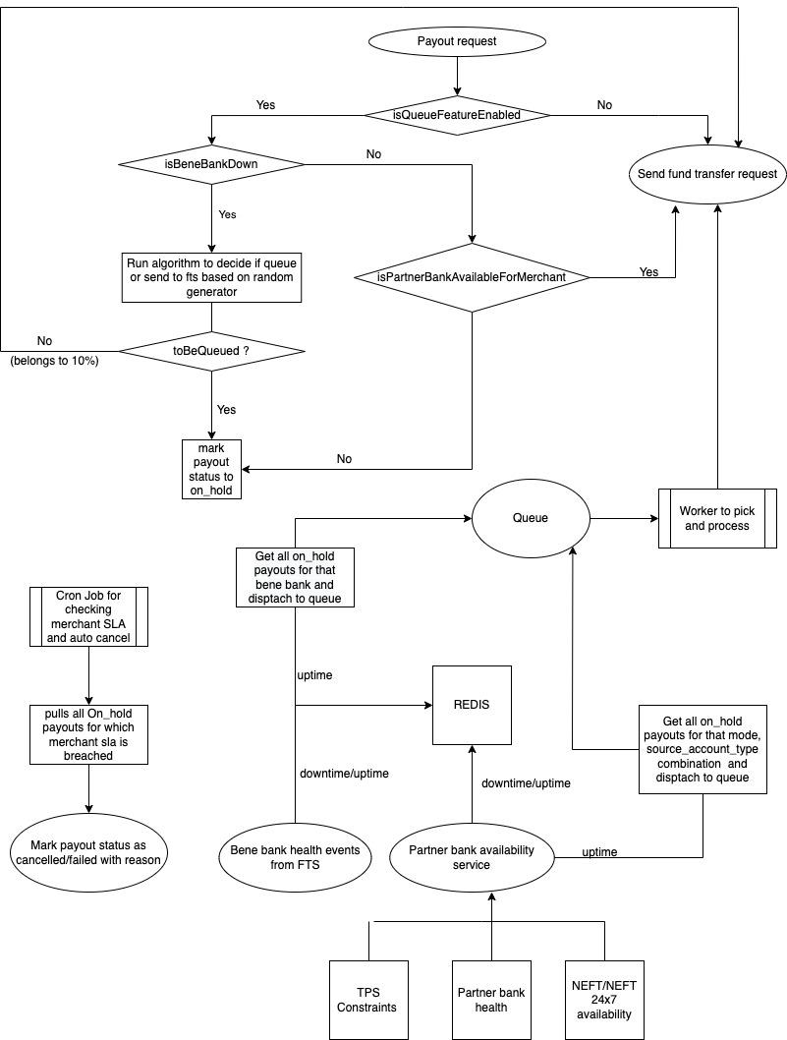
7.1.1 Send webhook to payouts for partner bank availability downtime/uptime
Implementation details:

Implementation of partner bank availability service in FTS
- A single point of contact which decides if a payout can be kept in On hold state due to partner bank unavailability.
- This service is responsible for interacting with diff modules such as partner bank health, NEFT 24x7 limit exhaustion, TPS constraints etc... which require a payout to be in On hold state.
- If partner bank is unavailable due to any of the above reasons, we send a webhook to payouts with a list of merchants. This is similar to what we do for partner bank downtime/uptime merchant communication.
- As part of V0, we’re considering only partner bank health module to hold payouts for both VA and Direct account merchants.
- Each event has fields “include_all”, “include_merchants” for a particular mode, account_type combination.
“include_all” - It’s a boolean which tells if payouts are to be kept On hold for all merchants.
“include_merchants” - It’s a list of merchants for whom payouts are to be kept On hold.

Examples of webhooks due to Partner bank downtime
{
"type": "partner_bank_on_hold",
"payload": {
"begin": 1621201835,
"account_type": "direct",
"mode": "IMPS",
"include_all": true,
"include_merchants": [],
"source": "PARTNER_BANK_DOWNTIME",
"status": "down",
}
}

{
"type": "partner_bank_on_hold",
"payload": {
"begin": 1621201835,
"account_type": "pool",
"mode": "IMPS",
"include_all": false,
"include_merchants": ["HYMtU0Y2OqcDX2","FB6QLNSY6KzO6d",...],
"source": "FAIL_FAST_DOWNTIME",
"status": "down",
}
}

Example of webhook due to Partner bank uptime
{
"type": "partner_bank_on_hold",
"payload": {
"begin": 1621201878,
"account_type": "direct",
"mode": "IMPS",
"include_all": false,
"include_merchants": [],
"source": "PARTNER_BANK_UPTIME",
"status": "up",
}
}

When to hold/release payouts for partner bank degradations ?

Option 1:
- Hold payouts for Partner bank downtime and release payouts for Partner bank Uptime.
- Pros:
  - Reliable lazy uptime detection avoiding fluctuations of bank.
  - Aggressive downtime detection.
- Cons:
  - According to partner bank downtime detection logic, we will hold payouts even if FR (Failure rate) is > 10% for > 4 min. This should be okay since we are targeting non SLA sensitive merchants and SR is more important for them.

Option 2:
- Hold payouts for Fail Fast Downtime and release payouts for Fail Fast Uptime.
- Cons:
  - Fluctuations from the bank can’t be handled by fast Fail fast uptime detection as it isn’t configured lazy similar to partner bank uptime detection.
  - Fail fast detects downtime only during very high degradations. Ex: FR>80%

Option 3:
- Hold payouts for Fail Fast Downtime and release payouts for Partner bank Uptime.
- Pros:
  - Reliable lazy uptime detection avoiding fluctuations of bank.
- Cons:
  - Fail fast detects downtime only during very high degradations. Ex: FR>80%
  - Coupling between two individual components of Fail fast, Partner bank downtime/uptime.

Preferred - Option 1

We want to detect degradation of partner bank health aggressively to move payouts to On Hold state. But for releasing the hold payouts, we want to resume the transactions a bit late without any fluctuations in bank health.

What triggers Partner bank availability service to interact with diff modules and take a decision to send the webhook to payouts ?

Option 1:
- Whenever a partner bank downtime/uptime event happens, partner bank availability service will interact with diff modules and send a webhook to payouts. Individual events would be sent for downtime/uptime.
- Pros:
  - No external dependency of cron Job.
  - Having a separate event for uptime will help to trigger releasing of on Hold payouts.
- Cons:
  - Webhook delivery may fail due to network issues and we can’t afford losing a single webhook especially uptime. This can be handled with a proper retry mechanism.
- We shall retry sending the webhook continuously until it succeeds or if there is a change in status of channel health. So, even if payout service goes down for x hours, webhook will be handled by the system without any manual intervention.

Option 2:
- We setup a cron with a frequency of x min which hits partner bank availability service and it sends a webhook to payouts with the updated list of on hold merchants each time. A single event is triggered each time with an updated list of merchants.
- Pros:
  - Even if webhook delivery fails for one event, cron job again hits partner bank availability service after x min and we would send the webhook to payouts.
- Cons:
  - External dependency of cron job. If cron job misbehave or fail, we would stop sending webhooks to payouts.
  - By having a single generic event, we should rely on some external cron jobs for releasing payouts that are in On hold state.
Preferred - Option 1

Partner bank availability service event consumption and it’s storage
- Payouts consume webhook sent by partner bank availability service and store the list of merchants and default value in redis for every mode, source_account_type combination with key and value as
partner_bank_on_hold::IMPS::direct::default - true
partner_bank_on_hold::IMPS::direct::list_of_merchants - []

- TTL of redis key will be x hr and if there isn’t any event for x hr, the key in redis will expire and payouts won’t be kept on hold for that particular mode, account_type combination.
- For every incoming payout request we first fetch the bene bank and check if it’s down. If it is down, we move the payout to on_hold.
- If bene bank isn’t down, then we check in redis for default value of partner bank unavailability for that mode, account_type. If it’s true, payout will be moved to the on_hold state.
- If the default value is false, we check if the given merchant exists in the list of partner bank unavailability merchants. If it exists, payout will be moved to the on_hold state. If it doesn’t exist, payout will be sent to FTS.

Dispatching the payouts on partner bank availability uptime event
- On receiving partner bank availability uptime event, we fetch the payouts that are in on-hold state for that mode, source_account_type combination and dispatch them to FTS.
- As part of V0, we aren’t merging this with bene bank and will be treated as an individual module.
  - We won’t be checking for bene bank health while releasing On hold payouts for partner bank uptime.
  - If a payout is initially marked on-hold for bene bank downtime and later if it got released during uptime, we then check if partner bank is down and mark it to on-hold state again.
- While dispatching payouts to FTS, rate limiter is applied which will help to not bombard FTS with high TPS.

Merchant config for defining queuing behaviour and SLA
- It will be similar to bene bank, which is:
  - The queuing behaviour will be managed by the feature flag.
  - Default SLA value to start with will be1hr.
  - The queuing SLA settings can be done in two ways:
- Using the settings table : We will have a global config for sla and for merchant specific sla config we can use settings table which we currently use for payouts_purpose and many other use cases.
- Using config key: We will have a global config for sla and the merchant specific sla can also be kept in config and override the global if merchant specific is present.
For phase I , we are not going to provide any config setting facility from the merchant or admin dashboard. So we can keep this in redis config and in v2 we can expose a route to the merchant dashboard for setting up an sla.

Options for a merchant during or after expiration of on-hold SLA for a payout.

Option 1 or Default behaviour:
- Payout is moved to failed state with reason as ‘no healthy partner bank is available’.
- Pros:
  - Payout is moved to final state within an hour/on-hold SLA. Sending it to partner bank may lead to unexpected behaviour such as payouts getting stuck for a long time.
- Cons:
  - If degradation for non availability of a partner bank is more than 1 hour, many payouts may fail.

Option 2:
- Process the payout as usual through the highest priority degraded partner bank after on hold SLA expires.
- Pros:
  - Few payouts may succeed based on the level of degradation from the bank.
- Cons:
  - Payouts may get stuck at the bank's end for a long time and we don’t have any control on them.

Preferred - Option 1

As part of Futuristic scope, we can provide a feature/ability for the merchant where he can cancel the payout that is in On-Hold state.

Auto cancellation of on-hold payouts on breaching the merchant SLA
- When a merchant SLA is breached we have to auto cancel the payout which is in on-hold state.
- The state marking on auto cancellation will be “failed” with the proper reason populated in the failure_reason field.
- A job to be added which looks up for the on-hold payouts for which SLA is breached in regular time intervals and accordingly mark them cancelled or failed.
- This job will also have a check if a partner bank is available for that merchant before failing, in case if it’s available and payout is on_hold it should not auto cancel and let it get processed.

7.1.2 Expose an API in FTS which tells if a partner bank is available for a merchant.
Implementation details:

Implementation of partner bank availability service in FTS
- A single point of contact which decides if a payout can be kept in On hold state due to partner bank unavailability.
- This service is responsible for interacting with diff modules such as partner bank health, NEFT 24x7 limit exhaustion, TPS constraints and deciding if the payout has to be kept in on-hold state.
- An API is exposed in FTS which tells if a payout has to be kept on hold.
- Payouts hits this API after bene bank downtime check and if the response is true, then it is moved to on-hold state.

Endpoint: “/v1/partner_bank_availability”
Method: “POST”

Request Body:
{
"mode": Required | String | Enum ("IMPS", "UPI", "NEFT"),
"merchant_id" : Required | String | Regex(`^[a-zA-Z0-9]{14}$`),
"source_account_type": Required | String | Enum ("direct", "pool"),
}

Response Body:
{
"hold_payout": true,
}

Cons:
- Every payout request has to hit the availability route in FTS before calling a transfer request and this may impact the processing time.

When to hold/release payouts for partner bank degradations ?
Same as 7.1.1

How to dispatch payouts to FTS once partner bank is available
Option 1:
- Dispatching the payouts on partner bank availability uptime event
- Pros:
  - No external dependency such as cron is required to resume payouts.
  - Reliable and will work at scale.
- Cons:
  - Risk of missing uptime events due to network issues. But this can be handled with a good retry mechanism as stated in 7.1.1

Option 2:
- Once payout is moved to on-hold state, it hits the availability route every x min.
- If the response is false, payout is sent to FTS and gets processed as usual.
- Pros:
  - No risk of missing any info due to network issues.
- Cons:
  - May have issues at scale. We can’t continuously hit the availability route if the no.of payouts in on-hold state increase.

Preferred - Option 1
Merchant config for defining queuing behaviour and SLA
Same as 7.1.1

Options for a merchant during or after expiration of on-hold SLA for a payout.
Same as 7.1.1

Auto cancellation of on-hold payouts on breaching the merchant SLA
Same as 7.1.1

7.2. Assumptions

7.3. Possibility of Open Sourcing

7.4. Possibility on Patent

7.5. Data model/Schema Changes
NA

7.6. Business Logic Changes

7.7. Miscellaneous Questions

8. Non Functional Requirements (NFRs)

8.1. Scalability

8.2. Availability

8.3. Security

8.4. Compliance

8.5. Reliability

8.6. Infra Cost

9. Feature Dependencies & SLAs
Callout upstream and downstream applications that will get impacted

9.1. Upstream Dependencies
Add SLO/SLA dashboard links for existing services.
Sr. No. | Service | Impact | SLA (if applicable) | POC for service

9.2. Downstream Dependencies
Sr. No. | Service | Impact | SLA (if applicable) | POC for service

10. Testing Plan
// TODO

10.1. Test Cases

10.2. UAT Testing

10.3. Performance/Load testing

11. Go-live plan

11.1. Production Rollout and Ramp plan
Add what will be done to progressively roll out the feature in production. You can take cues from product spec also to see how we can support the ramp up whether in a phased manner, in one shot or through certain gating criterias as needed.

11.2. Backward Compatibility

11.3. Rollback plan
Add what will be done in case of an immediate rollback requirement and how it will be implemented.

12. Monitoring & Logging
Jot down all metrics that need to be monitored for the changes being made

13. Milestones & Timelines
Breakdown the task into major milestone, divide the milestones to further task and subtask, mentioning owners, JIRA/Asana link, due date, reviewer, status
Creating a tabular sheet in excel is preferable here for better understanding
Please paste the link for the tracker with details similar to below here

Sr. No. | Title | Owner | JIRA/Asana link | Due Date | Reviewer | Status
1 | Milestone 1 (M1) | Aditi Maheshwari
2 | Milestone 2 (M1)

14. Glossary

This section describes all the terms and abbreviations being used specifically in the context of the above feature and heavily being used in this document.

15. Appendix

This section provides the links to all other important documents such as Project Milestone trackers, PRDs (created by Product team), Concept notes, JIRA/Asana project links and any other relevant links.

- Razorpay Product: Concept Note Template <June 2022>
- https://stackoverflow.blog/2020/04/06/a-practical-guide-to-writing-technical-specs/
- https://www.thecloudtutorial.com/technical-specification-document/

